**Patient treatment Model**

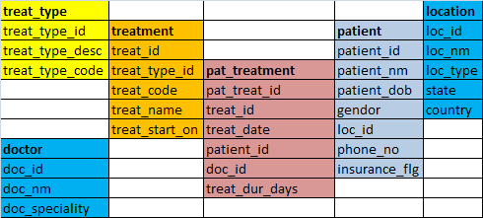

1. Find out different treatments we provide from last three years.
2. Find the number patients we get from each country
3. Find all the patients who are currently taking the treatment of type Ayurvedic
4. Find all the patients who are coming from metro cities (loc_type = 'Metro')
5. Find the number of customers who are having insurance
6. Find all the days where we provided more than 100 treatments in Ayurvedic type
7. Find the doctor who have the most number of treatments on 03-JAN-2013
8. Find the doctor who did not have any treatments on 03-JAN-2013
9. Find the treatments which were commonly given by both Doctor ‘RAM’ and ‘TIM’ gave on 03-JAN-2013
10. List treatment type, treatment name, Customer Country, Number of Customers who take Ayrvadeic treatment type.
11. Create a view which gives us the Patient Name, Country Name and the treatment they took in the current month. Call the view as vw_current_month_patients.

**Database Programming**

Create a function which takes the patient ID and returns the number of different treatments he / she took.

Create a procedure which takes month as an argument and return all the different treatments, no of different doctors who gave the treatment and the no of different patients who got the treatment

Create a star schema for the above mentioned data model.